**Activities to share at home…**

**Helpful activities for you and your child to do together:**

* Helping you around the house, e.g. setting the table, washing up, putting the shopping away
* Sitting together looking at a book and listening to stories
* Visiting places together like the park, supermarket, station, bank, library, post

office, launderette, castles, farms, parks etc

* Singing rhymes and songs
* Collecting things like buttons, shells, postcards or pebbles
* Playing together
* Playing outdoors

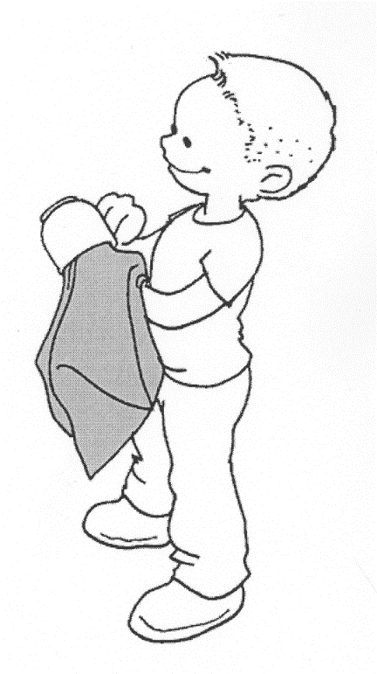

**Talking together:**

A child learns a lot from talking.

* Talk about:
* What happened today
* What you did today
* A television programme
* Things you like/dislike
* The games your child plays with other children

**Listening skills:**

It is important a child learns to listen. You can help by:

* Reading stories
* Learning rhymes and songs
* Taking turns in conversation
* Showing and explaining how things work

**All of these activities provide lots of opportunities for talking and sharing ideas with each other.**

**Activities like these will help to develop your child’s vocabulary and broaden their general knowledge of the world around them.**

**More activities to share at home…**

**Some simple games for all the family to play:**

* Snakes and Ladders and other board games
* Jigsaw puzzles with big pieces
* Snap or other matching games
* Colour or picture dominoes
* I Spy and other guessing games
* Picture lotto

Remember, learning is fun and exciting, involving new experiences and it is important to praise and encourage your child’s efforts.

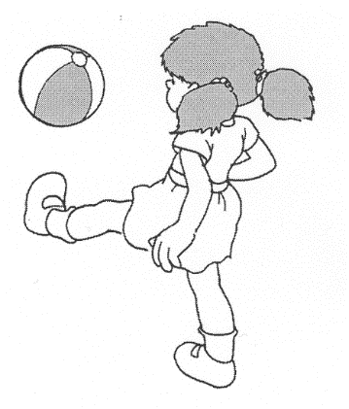

**Things your child should be able to do before they start school:**

Please ensure your child can do all of the following things independently …

Dress and undress him/herself Change shoes and plimsolls

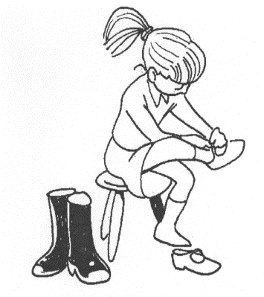

Put on and fasten his/her coat Use the toilet properly and flush it

Pull a zip up and down

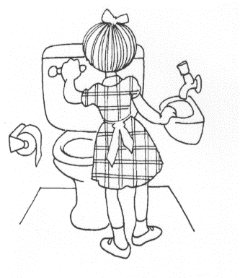

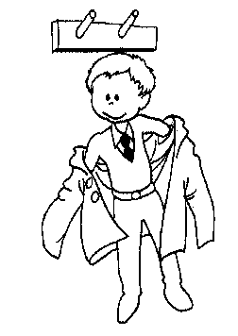

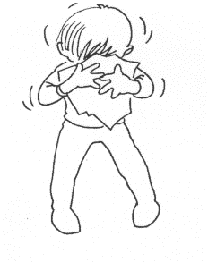

Blow his/her nose using a tissue Putt his/her hand over their mouth

and put it in the bin afterwards when they cough or sneeze

… and wash their hands after doing either of these

Wash and dry his/her hands and face Tidy/clear away his/her toys/work equipment

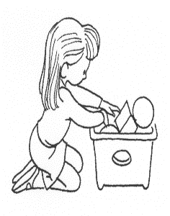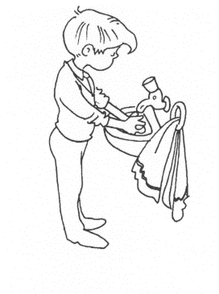

Use a knife and fork

It may be a good idea for your child

to practise putting on their PE kit,

taking it off and packing it away

in their PE bag.

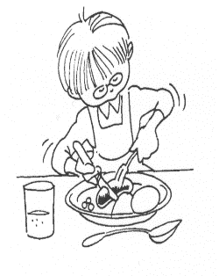

If you have any concerns or would like to discuss any of the things contained in this booklet, please do not hesitate to get in touch.

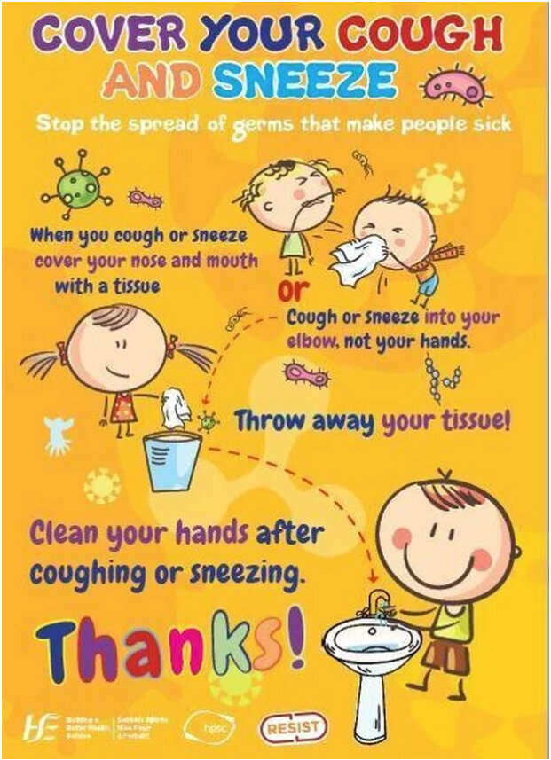

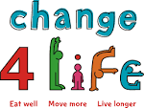

A recently published Public Health England paper entitled ‘How healthy behaviour supports children’s wellbeing’ has identified a link between children’s screen time and lower levels of wellbeing.

The paper has been released as part of a newChange4Life campaign which has identified 5 everyday changes which families can make.

The 5 ‘Smart Restart’ changes families can choose from are:

* stretch your legs – encouraging families to swap car or bus journeys for walking, scooting or cycling
* 10-minute moves – incorporating fun ten minute activities into lives to help build to the goal of at least 60 active minutes a day
* screen-time switch – encouraging limiting screen time and swapping time in front of the TV, tablet or computer for something active
* beat the treats – encouraging families to swap unhealthy treats for healthy alternatives
* super lunches – help keep children going through the school day with ideas for quick and tasty lunches