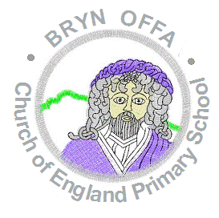
Bryn Offa C of E Primary School

Checklist of documents to be returned to school by Friday 12th June:

Document | Is this enclosed?
- Bryn Offa School Registration Form
- Home School Agreement
- Bryn Offa Acceptable Use Policy
- Cool Milk confirmation slip
- Uniform order form
- TRAN 1 application for free school transport (if applicable)

Please also bring your child’s Birth Certificate in to school so a copy can be taken for our records. A scanned email copy will also be acceptable.

