Can I recognise that different foods keep us healthy in different ways?

Have a look at these meals:

A. 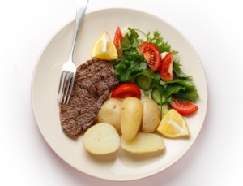 B. 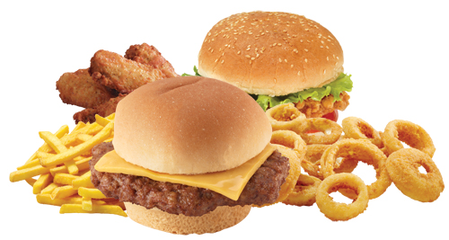

- Meal A is considered to be a healthy, balanced meal - why?
______________________________________________________________________________________________

- Meal B is OK as a treat, once in a while, but who might benefit from eating meals like this more regularly? _____________________________________________________________________________________________________________________________________________
_______________

- Why do we need a balanced diet?
______________________________________________________________________________________________________________________________________________________________________________________________________________________________________________________________________________________

