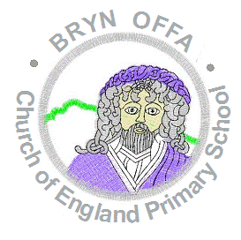

Bryn Offa C of E Primary School
Home School Agreement

Student Name
Class
Parent/Guardian’s name

School

We will:
- care for your child’s happiness, well-being and safety;
- encourage your child to do his/her best at all times;
- have a clear code of conduct and a set of rules to encourage good behaviour and self-discipline;
- help your child to develop positive values and attitudes through our Christian ethos;
- tell you about your child’s progress at parents’ evenings and through an annual written report;
- provide a broad and balanced curriculum;
- meet your child’s individual needs and help him/her to fulfil his/her potential; and
- keep you informed of school matters through regular letters and emails.

Parents/Guardians

I will:
- make sure my/our child attends school regularly, appropriately dressed in their school uniform and on time;
- pick my child up on time and inform school about picking up arrangements;
- phone school if my/our child is absent;
- encourage my/our child to behave well and follow the school code of conduct and school rules;
- attend parents’ evenings to discuss my/our child’s progress;
- support the school’s policies and aims;
- support my child with his/her homework;
- tell the school of any problems which might affect his/her work or behaviour; and
- follow the school’s ‘Use of Social Media Policy’.

Child

I will:
- arrive at school on time, tidily dressed and with all I need;
- do my best at all times;
- follow the school code of conduct and school rules;
- be polite, helpful and friendly to others;
- respect other people and their property; and
- keep the school tidy and put litter in the bin.

Signature of child: …………………………………………………………………………………….

Signature of Parent/Guardian: ……………………………………………………………………...

Date: ……………………………………………………………….

Signature of Parent/Guardian: ……………………………………………………………………...

Date: ……………………………………………………………….

