
EYFS and Key Stage 1
Reading at Home with your Child

R - Regular

Make time to regularly share books with your child. Find a cosy place and encourage snuggling up and sharing books together. Try to read to your child daily but don’t give up if you miss a day every now and then. When you’re reading, encourage your child to join in as much as possible. They are more likely to want to join in if they choose the book. You could encourage your child to copy the voices that you make.

Goldilocks and the Owl Babies by

three Bears story Martin Waddell
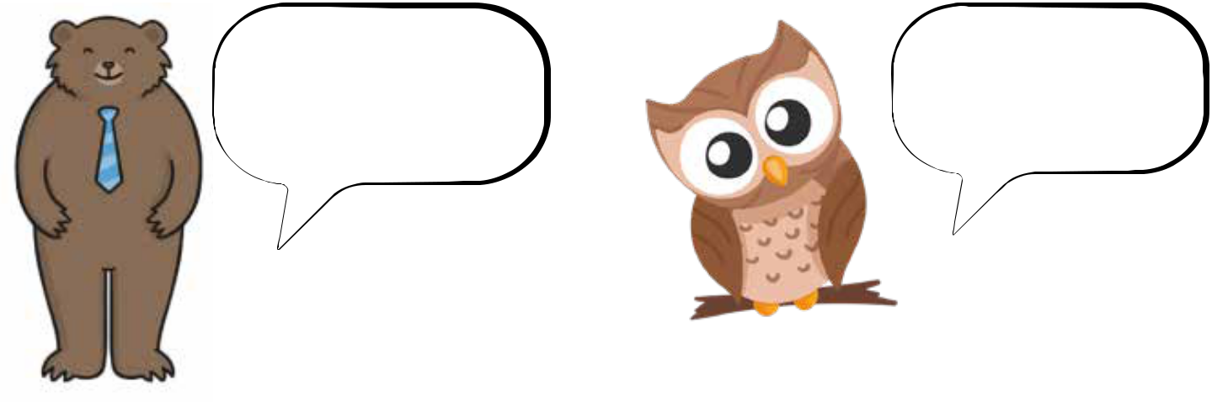

“Who’s been eating

my porridge?”

Gruff Daddy Bear voice

E - Enjoy

Read to your child, sometimes pointing to the pictures and the words. Talk about what is happening and try to relate the words and what is happening to your child’s own experiences.

What is Goldilocks doing?

What is she wearing in her hair?

Have you got a clip in your hair?

What kind of clip would you like?

“I want my Mummy”

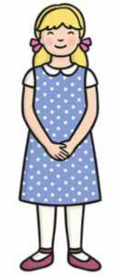
Tiny baby owl voice

Talk about the pictures and say the name of objects. Enjoy it! Encourage the whole family to join in – Dad, Mum, siblings, grandparents, care givers.

Join a library so that you have access to loads of books.

A - Ask questions

Ask lots of questions but make sure you give your child time to respond. Have a reading conversation that involves your child turn taking in a conversation.

Parent – “Look at that dog. It’s waiting for its dinner. Can you see the dog? What do dogs eat?

Child “…………………………………..….”

Parent – “I wonder what that dog will do after it has eaten its lunch? What do you think it will do?”

Child “…………………………………..….”

Parent “I’m looking forward to our dinner. What shall we make?”

Ask your child what they can see, what might happen next or what happened on the previous pages.

How do you think the girl is feeling?

What is the character saying?

Where is the bear hiding?

Encourage your child to ask questions too. Use the book questions on the book mark to encourage your child to talk about the story.

D - Do it again

Children often ask to hear the same story night after night. Stay patient and read favourite stories over and over again. Help your child to retell the story in their own words pointing to the pictures and turning the pages themselves. When talking about a familiar story, you could introduce new words. For example, “Yes the chair was too big for Goldilocks, it was too tall. It was a huge chair” Make sharing a favourite book joyful. Make reading feel easy.

I - Imagination

Get carried away by your imagination. Use funny voices and expression to make the story come alive! Make it sound like someone is talking. Ask your child how they think the character might say it. Can you make that part sound sad, exciting etc...? Use role-play to act out favourite parts of the story. Use teddies and toys as characters.

Book titles that are great to read with different voices and actions are:

We’re Going on a Bear Hunt Michael Rosen
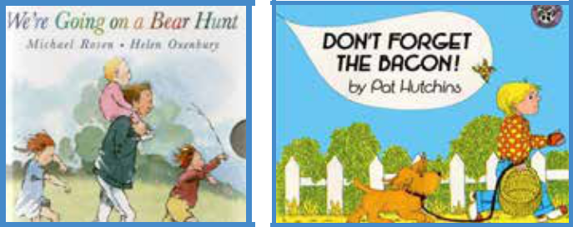

Don’t Forget the Bacon Pat Hutchins
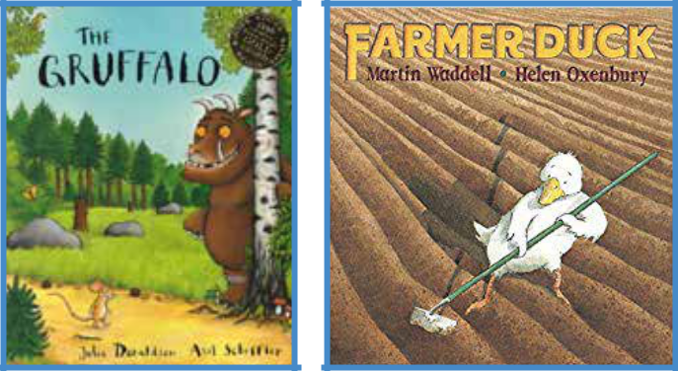

The Gruffalo

Julia Donaldson

Farmer Duck

Martin waddell

N - No fear

Your child needs to believe that reading is easy. They will be more willing to have a go if they don’t have any fear. Show that it’s ok to make mistakes. Ask, “Does that word make sense?” Praise your child if they try a word using their phonics, but if they don’t quite get it right, tell them the word.
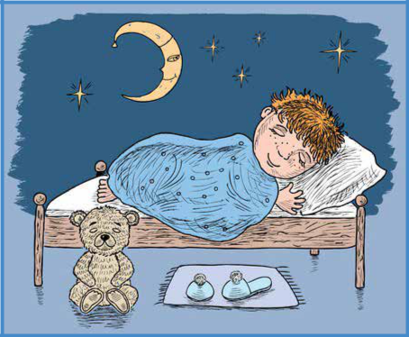

“The boy got in box. Oops, that doesn’t make sense. Let’s look at the picture. I can see a bed. I’m going to say the sounds in the word again and see if I can hear the word bed.”

The boy got in the bed.

Show your child how you read by pointing to one word at a time, move your finger to point to each word as you read. If your child wants to copy you and read the words again, celebrate any attempt that they make. It’s fantastic that your child wants to read just like you!

G - Games

Playing games that involve sounds will help your child to listen and hear differences in sounds and ultimately words. It is important for children to hear how sounds fit together to make words if they are going to have the skills that they need to read.

Play games that are fun and capture your child’s interests.

You can develop listening skills by making sounds of the things that they can see on a page and asking them to point to what is making the sound.
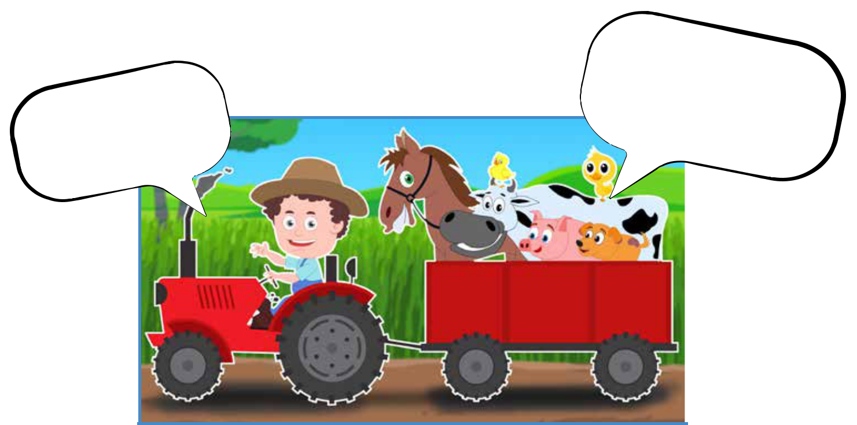

Can | you |  | oink
Can |  |  | pig?
Can |  | a | pig?
like |  | a | pig?

Moo,
What | is | moo!
What | is | making
that | noise?

If you’re feeling tuneful, you could sing ‘Old MacDonald’ and play along with drums or shakers!

A great way to engage your child is to sing fun songs. The Jungle Boogie is a great one to start with!

Listen to the song on - https://www.bbc.co.uk/teach/school-radio/nursery-rhymes-down-in-the-jungle/zfqgscw

Maybe you could go on a walk and see if you can hear any animals. Take your child outside and listen to the birds.

Children love learning Nursery rhymes and performing them with actions. Helping children to hear rhythm and rhyme is an important skill. If you say them often, your child will soon be able to say the missing word when you sing a rhyme and stop suddenly.

“Hickory, Dickory _________

The _________ ran up the _________.”

Use toys. If your child likes playing with dinosaurs, find a dinosaur that begins with different sounds.

As your child shows that they are able to listen to you and concentrate for short amounts of time you can begin to look at letters and sounds more closely. Flashcards are a great way to teach your child to recognise letters and use them to make words. They can easily be purchased from most toy shops and online stores.

If you prefer you could make your own set of fun flashcards for playing games with. Ask your child if they can make or read a word faster than you!
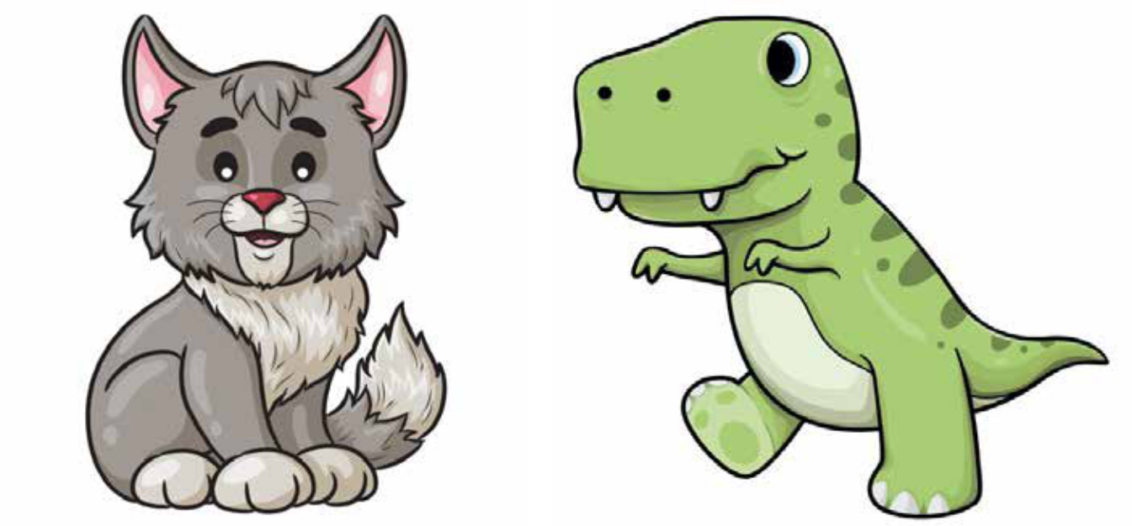

c a t “T for T-Rex”

Reading recipes and then baking together shows your child that reading has purpose. It’s great fun too!

