
Rhyme
Pack
For
Parents

Importance of Nursery Rhymes with your child?
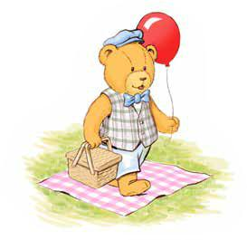
Sharing Nursery rhymes with your child is important because it provides your child with an opportunity to listen to language. Nursery Rhymes are shorter than stories and often have a catchy rhythm, which will leave your child wanting to hear more and join in.

Rhymes are fun and introduce your child to new and sometimes ‘funny’ words. They repeat words over and over which will help your child to say the words more clearly. The more rhymes that your child hears, the more words that they will learn.

Completing the activities in your pack will help your child to take turns in conversation, teach them to listen, teach them new words and allow them to talk about the world around them.

Tips to keep your child engaged

- Make your singing or reading session fun and exciting.

- Settle your child in a cosy place and get them ready to focus on the activity.

- Reward your child for joining in.

- Let your child turn the pages and point to the pictures.

- Read book and rhymes with pictures.
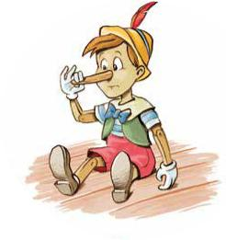

Tameside  READING 2

Tips to teach your child more vocabulary
- Chat with them all the time. Try to look at their face when talking and say what you are doing or what‘s happening in the room. “I’m putting my coat on, I’m stirring the tea.” When they try to respond, listen, look interested and praise them so that their confidence flies.

- Encourage turn taking in a conversation.

- Talk about what you can see on the pages of the book or the pictures in the rhyme.

- Talk about new words and what they mean.

- Give your child time to think about and understand what you have said.

Before you start -

Create the right environment

- You can help your child to learn language by reading and singing some of the Nursery Rhymes in this pack. Remember to make each session fun.

- Turn off any background noise from the TV or radio and try to face your child as you to speak to them so that they can watch how you make sounds with your mouth as well as listening.

- Put a hand to the ear alongside listen will give vital clues to children Give your child lots of smiles and cuddles and remind them how clever they are for joining in the fun. The more you encourage them, the more they will join in.


- Each of the Nursery rhymes in this pack has simple games and activities which will develop your child’s communication and language skills. Tips and games can be found at the end for use with any Nursery Rhyme.

- As Parents and Carers, you have a unique opportunity to help your child at the very beginning of their learning journey. Singing

Nursery Rhymes has been proven to help your child’s language and communication development.

Bedtime fun
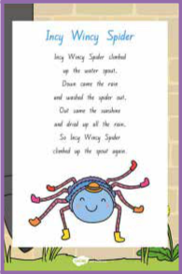

This has been snipped from a twinkl site and would need to be a full page with the games and instructions below on the back. The card would be laminated.

Sing

Sing the rhyme on the way to bed. (Don’t worry about the sound of your voice children love listening to music and find it soothing and calming.) Sing it as many

times as your child enjoys. Change the sound of your voice and sing it like a bear!

Join in with a video clip - www.bbc.co.uk/teach/school-radio/ nursery-rhymes-incy-wincy-spider/

Actions

Sit opposite your child so that they can see your face. Sing the rhyme and make spider like actions with your fingers as you sing. Encourage your child to join in and when they do give them lots of praise. Run your fingers up their arm like a spider and ask if the spider tickles! Wiggle your finger as you sing ‘down came the rain.’ Wave your arms in circle motions as you sing ‘out came the sun.’

Play


Move your fingers over the palm of your hand and say ‘spider’. Repeat creating a long exaggerated ‘ssssssss’ at the beginning of spider. Help your child to use their mouth correctly to make the ‘s’ sound.

Word fun

Sing the rhyme and repeat the word ‘spout’. “Say that it’s a funny word and t means the drain pipe on a house that carries the water off the roof to the ground.” Look out of the window and look at drain pipes. How many spouts can you see from the window? Explain that the spider was trying to climb up the pipe but the rain washed him out!

Explain that you are looking for the word ‘spider’ and that it begins with a ‘s’ sound. Draw a ‘s’ shape in the air as you make the sound. Point to a ‘s’ on the Nursery rhyme card. Point to several explaining that they are all the same. Ask your child to find one and say ‘s. ‘S for spider.’

Show your child that they can find out more about spiders in the information book. Talk about the photographs of spiders in the book. As your child if they know where spiders live and what they eat? Use the book to find out more about spiders together.

Bathtime fun

Sing

Sing the rhyme in the bath. (Don’t worry about the sound of your voice children love listening to music and find it soothing and calming.) Splash the bath water each time you sing ‘water’. Sing the rhyme as many times as your child enjoys.

Join in with a video clip after the bath - www.bbc.co.uk/teach/ school-radio/eyfs-listen-and-play-jack-and-jill/
Actions

Face your child, sing the rhyme and each time that you sing ‘fetch a pail of water’, scoop up and fill a small container with water. Encourage your child to join in and when they do give them lots of praise. Explain that a pail of water is a bucket of water.

Play

Ask your child which toys in the bath they can fill with water. As you sing the rhyme together scoop up the water in different cups and containers. Act out spilling the water. Pretend to be Jack and splash and spill the water.

Help your child to use their mouth correctly to make the ‘w’ sound. Repeat ‘w,w,w,w, water.’ Encourage your child to say the sound ‘w’ in a quiet and loud voice.

Word fun

Once out of the bath, look at the picture of the rhyme. Explain that you wonder why Jack and Jill needed water. Talk about all the things that you use water for: having a bath; making a drink; washing clothes; watering the plants.

Show your child the ‘Jack and the beanstalk’ story. Explain that this story also has a little boy called Jack in it but he’s not looking for water. Cuddle up together and read the story.

This has been snipped from a sparklebox site and would need to be a full page with the games and instructions below on the back.

The card would be laminated.
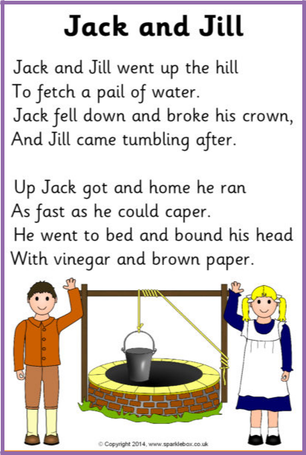

Breakfast fun

Sing

Make hard boiled eggs for breakfast and rest an egg in an egg cup.

Sing the rhyme and crack the lid off the egg so that it can be eaten.

Show the picture and rhyme. Explain that Humpty Dumpty is and

egg and he can crack and break. Crack the now empty egg shell

whilst repeating

the rhyme.

Join in with a video clip after breakfast – www.bbc.co.uk/teach/ school-radio/nursery-rhymes-humpty-dumpty-sat-on-the-wall/

Actions

Face your child, and rock from side to side as you sing the rhyme. Each time that you sing ‘had a great fall’, wobble over. Encourage your child to join in and when they do give them lots of praise.

Pretend to ride a horse as you sing ‘all the Kings horses and all the Kings men.’ Look at the picture of the horses. Trot/gallop around the room making horse noises.

Play

Make and break up lots of jigsaws together. Talk about how poor Humpty Dumpty couldn’t be put back together but jigsaws can. Challenge your child to complete a jigsaw in the fastest time. Can you put a jigsaw back together again?’

Word fun

Build a wall out of toy bricks and then knock it down. Go on a walk and look at the bricks on houses and walls.

Read Each Peach Pear plum and ask your child to see if they can spot Humpty Dumpty hiding in the pictures. Give your child some paper and pencils and try and draw Humpty Dumpty together.

This has been snipped from a sparklebox site and would need to be a full page with the games and instructions below on the back.

The card would be laminated.
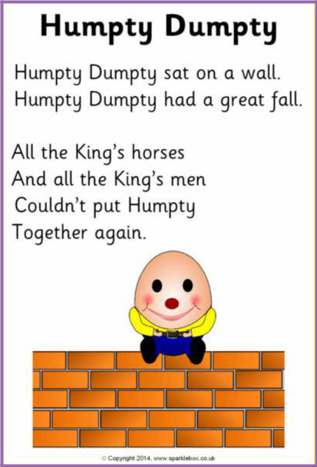

More Nursery Rhymes to sing and watch with your child.

www.bbc.co.uk/cbeebies/curations/nursery-rhymes


Twinkle twinkle

Teddy bear picnic

Row row row your boat

If you’re happy and you know it


The wheels on the bus

Old McDonald

I can sing a rainbow


A sailor went to sea

Sleeping little bunnies

Hey Diddle Diddle

