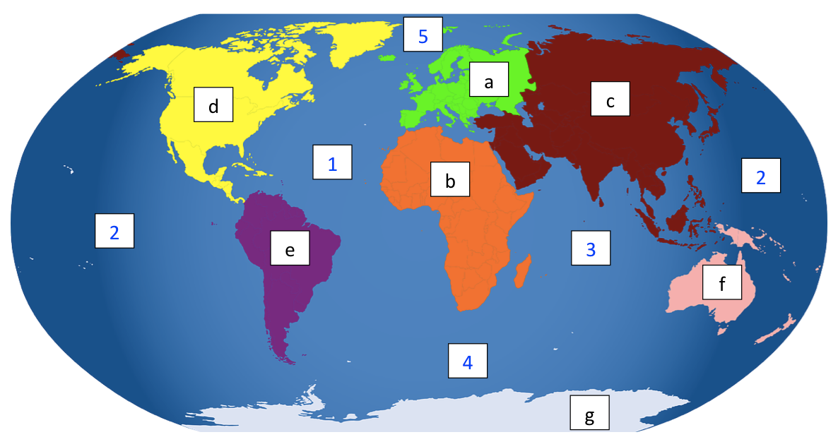
Africa
Europe
Asia
North America
South America
Australia
Antarctica
Indian Ocean
Pacific Ocean
Southern Ocean
Atlantic Ocean
Arctic Ocean
Continents:

E

a) _____________________________ Oceans:
A
I
A
b) _____________________________ 1) _____________________________
P
A
c) _____________________________ 2) _____________________________
N
d) _____________________________ 3) _____________________________
S
A
e) _____________________________ 4) _____________________________
A
A
f) _____________________________ 5) _____________________________
A
g) _____________________________

Extension: Look at an atlas to find out the answers.

a) Which continent is the UK in? _______________________________________

b) In which continent is Brazil? _______________________________________

c) Which continent is Egypt in? _______________________________________

