To all stakeholders involved in School Transport & other Council Passenger Transport

Date: 12th August 2020

Dear Consultee,

**School Transport in Shropshire - Updated School Covid-19 Safe Transport Policy September 2020 – Consultation**

The Government are re-opening all schools and asking that all pupils return in September 2020.

A raft of Government safety measures and guidelines are in place to make this as safe as possible.

The updated and revised Shropshire Council transport guidance is based on the latest national Government advice, including that from both DfT and DfE. As the guidance suggests transport pressures vary greatly and Shropshire has its own precise and unique challenges, therefore solutions in relation to transport planning for the wider return of school children must and have been locally led.

Transport from home to school is a key aspect of the return to school by pupils and our Passenger Transport Group have now updated its June 2020 guidance document ready for September 2020.  The document makes reference to both pupils entitled to free school transport and to those who are not, to public and dedicated contracted school transport alike, and to other travel aspects, along with transport in other service areas such as Adult Services.  The document is intended to advise and guide transport operators, schools, parents, pupils, other passengers and other transport reliant services and stakeholders.

The revised version for September 2020 is attached for your consultation, consideration and comments, which we’d be grateful to have returned to us by Noon on Friday 14th August 2020. Due to the unprecedented times we are in we have unfortunately have a very condensed timescale to get information out to you in order to publish the new document two weeks before schools return.

Your support is much appreciated.

Yours faithfully,

Passenger Transport Group

Shropshire Council

107 Longden Road

Shrewsbury

SY3 9DS

Email: [passtrans@shropshire.gov.uk](mailto:passtrans@shropshire.gov.uk)

DRAFT 120820

Shropshire Council

- Passenger Transport Group -

Coronavirus (Covid-19) Emergency

Guidance for School Transport & other Council Passenger Transport from

September 2020

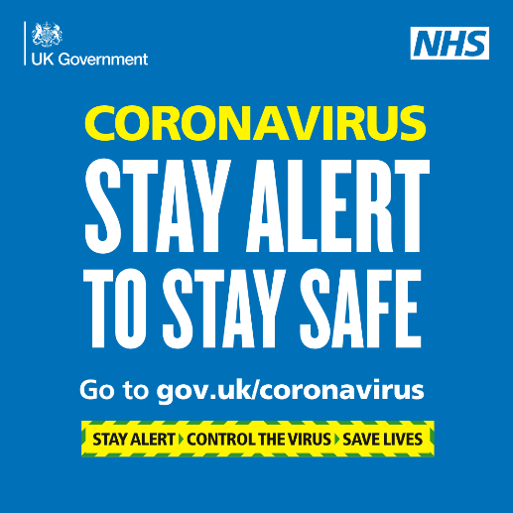

**Introduction**

As the Coronavirus (Covid-19) emergency continues, Shropshire Council is working to re-activate all its home to school transport for entitled pupils from September 2020.

Government has decided that all schools will re-open in September 2020 and all pupils will return to school. They have issued advice (e.g. Department for Education Transport to School and other places of education; Autumn Term 2020, published 11th August 2020) about how this will be achieved, and the Council is following this guidance as it re-activates the school transport network.

To keep everyone as safe as possible, we will rely on stakeholders’ full cooperation in following this guidance – this includes operators, staff, parents, pupils and schools. Only by all of us working together will we keep everyone safe as they can be. This offer of Covid-19 safe school transport is made by the local authority to parents/pupils, but if parents/pupils do not wish to accept the offer, they can make their own alternative arrangements for transport to and from school.

All sections of the guidance below are relevant to all stakeholders and should be read by everyone – the different sections are intended to better group the guidance and provide a focus for different stakeholders, and are as per:

* Government Safer Travel – Key Points
* General Covid-19 Guidance
* Operators
* Parents/Pupils
* Schools
* SEND Transport
* Local Bus Services (Public Buses)
* Adult Social Care
* Other Passenger Transport Provision
* Summary

The guidance sets out how provided school transport in Shropshire is to resume and these plans will be updated as the Coronavirus (Covid-19) emergency develops and changes (locally and nationally), and as Government advice is updated or altered.

This guidance should be followed by all Council passenger transport contractors/operators, schools, parents/pupils, and also care centres and carers.

**Government Safer Travel – Key Points**

For information, a quick reference to key Government travel guidance is shown below and these points are amplified further into this guidance document:

* Pupils should not travel if feeling unwell or if they have any Covid-19 symptoms
* Providing the most on-bus ventilation possible, consistent with a comfortable journey
* Enhanced bus/taxi cleaning regimes, particularly for regular touch points
* Keeping any physical contact to the minimum
* Avoid touching your face where practical
* Covering mouth and nose with a tissue or the inside of the elbow when coughing or sneezing
* Travelling side by side or behind other people, rather than facing them, where seating arrangements allow
* Touching as few surfaces as possible
* Minimising the time spent close to other people, where possible
* Avoiding loud talking, shouting or singing
* Facing away from others
* Wash hands for at least 20 seconds or sanitise hands before and after the end of your journey

**General Covid-19 Guidance**

*Principles*

1. Safety of staff, pupils and the public will be paramount
2. Government Covid-19 advice for passengers is at this link:

<https://www.gov.uk/government/collections/coronavirus-covid-19-list-of-guidance#transport>

1. And Government advice for operators is at this link:

<https://www.gov.uk/government/publications/coronavirus-covid-19-safer-transport-guidance-for-operators/coronavirus-covid-19-safer-transport-guidance-for-operators>

*Illness/Shielding*

1. Drivers, Passenger Assistants and pupils should not travel on transport if they are feeling unwell, particularly if they have symptoms of coronavirus (COVID-19) which include a new, continuous cough, high temperature, or loss of taste or smell, or if they live in a household with someone showing any of these symptoms – they should self-isolate and stay at home.
2. Any pupils becoming ill at school should be taken home by their parents (NB parents should have transport contingency arrangements in place to do this)
3. Guidance on shielding and people/pupils who are high risk (clinically extremely vulnerable) can be found at the Government web link below:

<https://www.gov.uk/government/publications/guidance-on-shielding-and-protecting-extremely-vulnerable-persons-from-covid-19/guidance-on-shielding-and-protecting-extremely-vulnerable-persons-from-covid-19>

*NHS Test and Trace*

1. Drivers and passenger assistants should book a Covid-19 test if they display symptoms (as described above) and families should do likewise if their children display symptoms.
2. They should also provide details of anyone they have been in close contact with if they were to test positive for coronavirus (COVID-19) or if asked by NHS Test & Trace.
3. A person should [self-isolate](https://www.gov.uk/government/publications/covid-19-stay-at-home-guidance/stay-at-home-guidance-for-households-with-possible-coronavirus-covid-19-infection) if they have been in close contact with someone who develops Covid-19 symptoms or someone who tests positive for Covid-19

*Shared School Transport*

1. Where two different schools have previously shared the same transport, the Council is now providing additional separate transport from September 2020 in order to separate pupils from different schools.

*Hygiene*

1. At all times, everyone should maintain good hand hygiene (e.g. washing hands with soap and water or alcohol hand sanitiser, particularly straight before and straight after journeys), avoid direct hand contact with eyes, nose and mouth, and use tissues to catch coughs and sneezes (or at least to cough/sneeze into the crook of their elbow) disposing of tissues in a bin as soon as possible (i.e. ‘catch it, bin it, kill it’)
2. Coronavirus (COVID-19) is an easy virus to kill when it is on skin. This can be done with soap and running water or hand sanitiser prior to and after their journey to school.

*Self-Isolation*

1. If pupils have any symptoms of Coronavirus Covid-19 they should self-isolate at home and [arrange to have a test to see if they have coronavirus](https://www.nhs.uk/conditions/coronavirus-covid-19/testing-for-coronavirus/).  If anyone in their household or [support bubble](https://www.gov.uk/guidance/meeting-people-from-outside-your-household#making-a-support-bubble-with-another-household) has symptoms of Coronavirus Covid-19 they should self-isolate.
2. Children, drivers and Passenger Assistants who have been in contact with someone who has developed symptoms whilst at school or on home to school transport do not need to go home to self-isolate unless i) they develop symptoms themselves (in which case, they should arrange a test), or ii) the symptomatic person subsequently tests positive, or iii) if they have been requested to do so by NHS Test and Trace.

*Loading Capacities*

1. Whilst provided school transport will operate to full loading capacities from September 2020, public transport (local bus services and trains) will remain at less than 50% capacity. The government is urging parents to arrange for pupils not entitled to free transport who normally use public buses to get to school to walk or cycle instead, if they can, or to use alternative means of getting to school. This will ease capacity pressures on public transport and avoid pupils travelling with the public.
2. On certain public transport services in Shropshire which are used by many pupils and where there is a high risk of buses not being able to carry all the pupils/passengers wanting to travel, at the request of Government the Council will be providing additional buses/coaches to supplement the main public service bus
3. The Government information poster below highlights the importance of using a tissue to catch coughs and sneezes:

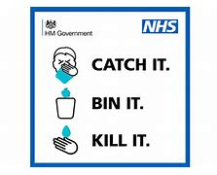

**Operators**

*September 2020*

1. All pupils will return to school and dedicated contracted school transport bus/taxi networks will return to ‘normal’ within these Covid-19 safety guidelines, wef September 2020

*Cleaning*

1. Coronavirus (COVID-19) is understood to be easy to kill on surfaces - normal cleaning products will do this. Operators should ensure that all touch points on school transport vehicles have been cleaned to protect against Coronavirus (Covid-19) prior to and after every new journey – this includes door handles, keys, handrails, armrests, seat backs, seatbelts, driver controls, etc. [NB operators should contact PTG if they have any difficulties in sourcing appropriate cleaning supplies/PPE]
2. On-board disposable cleaning fluids/cloths/disposal gloves and a suitable secure on-board bin for disposal of any cleaning items, tissues or PPE, for in-journey use, should be provided

*Staff*

1. Staff employed by operators should avoid mixing with each other where possible and that operators should support individual workers who choose to use face coverings in situations where social distancing is not possible.

*Seating*

1. From September 2020 there will be no social distancing on dedicated contract (closed) school buses and taxis, which means that vehicles will operate at 100% capacity – it’s important to note that no members of the public travel on these buses and they are restricted to the same group of pupils each day
2. The default seating arrangement on school buses will mean that each pupil uses the same seat each day and that they are grouped in their Year Groups (‘bubbles’), with the eldest pupils seated at the rear of the bus and progressively younger Year Groups sitting towards the front of the bus, as described in the ‘bubble’ seating examples below. Where it is possible, individual pupils and ‘bubbles’ should be as distanced as possible from each other, preferably by an empty row of seats or more. Once the seating arrangements are established, where possible they should be replicated daily.
3. Siblings from the same household can sit next to each other, even if they are in different ‘bubbles’

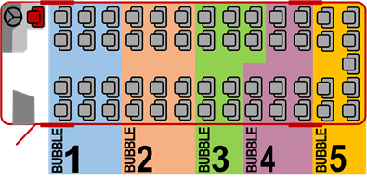

*NB Eldest pupils in Bubble 5, progressing in age reduction order to youngest in Bubble 1*

A ‘Seven-Bubble’ seating example is below.

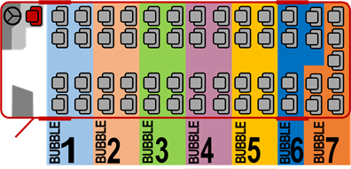

*NB Eldest pupils in Bubble 7, progressing in age reduction order to youngest in Bubble 1*

1. Drivers are expected to advise on safe travel and instruct pupils about safe seating arrangements, but they are not expected to police arrangements such as seating plans, queues or the wearing of face covering – their role is to focus on driving the vehicle safely

*Ventilation*

1. Operators should provide good vehicle ventilation when carrying passengers (such as opening windows where practical) to help reduce the chance of potential airborne infection

*Infection Control*

1. Drivers and Passenger Assistants may wish to use alcohol hand sanitiser at intervals throughout the journey and should always do so after performing tasks such as helping a child into the vehicle or handling a child’s belongings.
2. At the end of their shift, drivers and Passenger Assistants (PAs) should minimise possible contamination before entering their own home – key things to do include washing with soap and water, and isolating clothes and personal effects in a box prior to cleaning
3. Where school ‘link’ or ‘feeder’ transport is provided, we may revise the arrangements and provide the transport directly to the end destination, to reduce contact and journey time.
4. When boarding takes place at school or at a hub, drivers may stand off the bus 2 metres away from boarding pupils/passengers; drivers should not congregate
5. For disability transport (whether by taxior accessible bus) operators should take account of the ambulance trusts’ procedures for transporting someone without covid-19 symptoms where social distancing is not possible (i.e. particularly, please see ‘Table 4’ infection control) shown at:

<https://www.gov.uk/government/publications/covid-19-guidance-for-ambulance-trusts/covid-19-guidance-for-ambulance-trusts>

*Face Coverings*

1. Whilst pupils over 11 years should wear face coverings whilst travelling, they should not be refused transport if they (occasionally) have no face coverings. And wearing face coverings may not always be possible, particularly for SEND pupils or if exemptions apply.  Where pupils who should wear face coverings do not, they should be reminded that they should do so, and operators should report any such instances to the Council and the school.
2. Drivers/staff can wear face coverings/visors where social distancing is difficult

*Government Guidance*

1. Government (DfT) advice for operators should be adhered to and can be found at the following link:

<https://www.gov.uk/government/publications/coronavirus-covid-19-safer-transport-guidance-for-operators/coronavirus-covid-19-safer-transport-guidance-for-operators>

*Taxis*

1. On Taxis and Private Hire vehicles, drivers and pupils over 11 years should wear face coverings and use sanitising hand gel both on entry and disembarkation.  Whilst ideally we would like to restrict pupil numbers on taxis to two pupils in the rear seat, with the middle rear seat and front seat unoccupied, this may not be possible in many cases.  In reality the infrastructure to provide this is unavailable and/or it is logistically difficult.
2. Taxi operators should follow guidance issued by Shropshire Council’s Taxi Licensing Team
3. Pupils/passengers should follow the advice of the driver. For example, you may be asked to sit in the back left-hand seat if travelling alone.

**Parents/Pupils**

*Illness*

1. Pupils should not travel if unwell or if they have been told to isolate
2. Parents may wish to routinely take the temperature of their children, and whilst a high temperature (e.g. above 37.2 degrees centigrade) is not a method for identifying Coronavirus (COVID-19), it could identify if a child is ill, in which case the child should not attend school whatever the cause of any illness. If in doubt, parents can contact their school for advice.
3. If any pupils become ill during the journey to the school, the school should be notified immediately – the school may then contact their parents to collect them from school

*Boarding*

1. Boarding buses should be done one at a time - disembarking buses should also be undertaken one at a time, from the most forward seats first, with pupils staying apart

*Hand Sanitiser*

1. Pupils should sanitise their hands when boarding buses/taxis – if available, they can use operator provided hand gel and/or they can carry their own (i.e. 60%+ alcohol hand gel); parents may wish to advise pupils to sanitise their hands regularly during the journey as well

*Face Coverings*

1. Pupils over the age of 11 should wear a face covering whilst travelling on provided transport, and not to touch the front of their face covering during use or when removing it. (NB Pupils aged 3-11 years can wear a face covering as well, if parents so wish). Government guidance on face coverings can be found at the following link:

<https://www.gov.uk/government/publications/face-coverings-when-to-wear-one-and-how-to-make-your-own/face-coverings-when-to-wear-one-and-how-to-make-your-own>

*Seating*

1. See points 22 – 25 above
2. In particular on boarding, pupils should go straight to their usual seat, and sit down
3. Where primary school pupils have difficulty fitting seat belts themselves, the driver should offer verbal guidance and support from a safe distance – seat belts should be pre-adjusted for pupil use
4. Pupils travelling on coaches should stay seated for the whole journey, face forwards, not touch other pupils, not shout or sing and use a tissue to catch any coughs or sneezes

*Infection Control*

1. On arrival at school, pupils must wash/sanitise their hands immediately for 20 seconds and dispose of temporary face coverings in a covered bin or place reusable face coverings in a plastic bag they can take home with them, and then wash their hands again before heading to their classroom*.*
2. We would encourage pupils to carry tissues with them on the bus/taxi, to use to cover their mouth/face if they sneeze, cough or wish to blow their nose – used tissues should be disposed of safely and not shared



1. Where possible pupils should social distance on a school site or at a transport hub, where multiple vehicles may be present where loading and unloading is required, and school staff may supervise on-site unloading/loading
2. As a general rule, not just when using transport, pupils and staff should maintain good hand hygiene, regularly washing hands with soap and water or alcohol hand sanitiser for 20 seconds. This is particularly important straight before and straight after journeys. As best as they can, everyone should also avoid direct hand contact with eyes, nose and mouth, and use tissues to catch coughs and sneezes (or at least to cough/sneeze into the crook of their elbow), disposing of tissues in a bin as soon as possible

*Risk*

1. Where pupils/passengers present an unacceptable safety risk to other pupils/staff, they may be refused transport (e.g. for reasons including displaying illness, deliberate spitting, coughing and sneezing at others, touching others, shouting, singing, not sitting in their ‘bubble’, standing, seat switching, ignoring verbal safety guidance)

*Temporary Seats Payment Scheme*

1. The Council’s Temporary Seats Payment Scheme which uses spare seats for non-entitled pupils will not operate until further notice. This is to free up as many spare seats as possible to provide more social distancing measures.

*Parental Travel Budgets*

1. Whilst our new arrangements for providing home to school transport follow Government guidance, parents of pupils entitled to free school transport may decide to make alternative arrangements out of personal preference. Parental Travel Budgets or mileage allowances can be considered as an alternative transport offer, upon application. The Council will determine whether or not it can provide a Parental Travel Budget in each individual circumstance.

*Public Buses*

1. Where non-entitled pupils travel on public transport (LBS) also used by the public, because loading capacities on public buses will still be less than 50% in September 2020, parents are being encouraged to find alternative ways of getting their children to school – if they live in the same town/community as the school, active travel (walking/cycling) should be the first choice. The second choice should be travel by car.   Only if none of these options are available to parents should they attempt to use public transport.

*Park & Stride*

1. For pupils not entitled to free school transport, parents will make appropriate arrangements to get their children to and from school.  Many pupils walk or cycle to school themselves.  Where parental cars are used instead, a ‘Park & Stride’ strategy can be used – this is a simple solution that allows pupils to walk for part of their journey and where parents safely park a little further away from school, typically within a 5 to 10 minutes walking distance. Parents will decide whether or not to escort their children to and from school on the ‘Stride’ element of the journey. ’Park & Stride' helps reduce entry risks at the school and eases access overall.

*School Gates*

1. Parents and pupils should avoid congregating at the school gates and keep these areas free for unhindered access and egress of the school site. Any parents who do escort children to the school gates should exercise social distancing at all times.  Also, face coverings can be worn.  This reduces the risk of Coronavirus and helps with road safety.

*Government Guidance*

1. Government (DfT) advice for passengers should be adhered to and can be found using the following link:

<https://www.gov.uk/guidance/coronavirus-covid-19-safer-travel-guidance-for-passengers>

**Schools**

*DfE Guidance*

1. Guidance from the DfE about school transport is contained within their publications at the following links:

<https://www.gov.uk/government/publications/what-parents-and-carers-need-to-know-about-early-years-providers-schools-and-colleges-during-the-coronavirus-covid-19-outbreak/what-parents-and-carers-need-to-know-about-early-years-providers-schools-and-colleges-in-the-autumn-term>

<https://www.gov.uk/government/publications/what-parents-and-carers-need-to-know-about-early-years-providers-schools-and-colleges-during-the-coronavirus-covid-19-outbreak/what-parents-and-carers-need-to-know-about-early-years-providers-schools-and-colleges-in-the-autumn-term>

*Bus and Taxi Routes*

1. Any changes requested by schools to established transport arrangements to accommodate Covid-19 measures at school will be considered using the following criteria:

* Compliance – are revised arrangements compliant with Government Covid-19 guidance?
* Capability – is the transport operator capable of providing the revised transport?
* Cleaning – has the transport operator time to clean vehicles between trips?
* Consistency – are the transport changes consistent over time?
* Cost – are there any cost implications?

*Face Coverings*

1. Schools should have a process for pupils to remove and safely disposing of face coverings when arriving at school

*Bus Seating*

1. Seating arrangements on buses are important in making transport safer - we ask that schools support the pupil seating template outlined in the Operator section above, namely that each pupil uses the same seat each day and that pupils be grouped in ‘bubbles’ according to their Year Groups, with the eldest pupils seated at the rear of the bus. Individual pupils and ‘bubbles’ should be distanced as far as practically possible from each other, with a seat row between ‘bubbles’ where loadings allow. Once the seating arrangements are established, they should be replicated each and every day.

*Public Buses*

1. To avoid overloading the public transport network, which is still operating at limited capacity, Government have asked that pupils who normally use public buses to get to and from school should walk or cycle instead, where possible. They say that public buses should be used as little as possible and schools’ support is important in helping achieve this.

*Boarding Buses*

1. Schools are also asked to assist in organising safe queuing and boarding for the return journey home

*Poster*

1. A Government information poster below emphasises the need to stay alert:

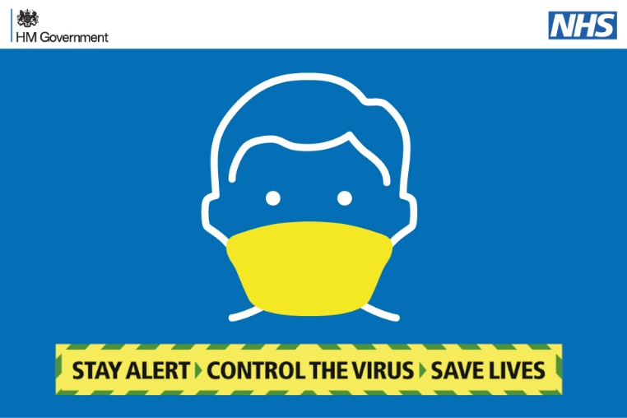

**SEND Transport**

*PPE*

1. Drivers and Passenger Assistants will wear PPE appropriate to the risk assessment for their role, the pupils on board and the nature of the staff interaction with them.
2. When applying or removing fluid resistant face masks or other PPE, it is important that the wearer’s hands are washed/cleansed for 20 seconds before and after each use

*Pick Up Points*

1. At pick up points, where staff receive passengers from their parents/carers, social distancing guidance must be adhered to and alcohol hand sanitiser used by pupils and staff; staff should stay as far away as they can from parents/carers and spend as little time near them as possible; staff should avoid any physical contact with house doors, gates or parent/carer property or belongings

*Risk Assessment*

1. An additional risk assessment should be carried out where circumstances change or where there are additional issues present. Parents will be contacted directly if they are affected by this.

*Medication*

1. For pupils/passengers who may require ‘rescue medication’ on the transport itself, transport will only be provided where a further risk assessment has been carried out, so that potential infection risk can be properly managed. Staff administering rescue medication will be trained to do so and wear appropriate PPE, which may include gloves, apron, mask and visor

*Seating*

1. If the PA needs to fasten a passenger’s seat belt/harness, this should be done with minimal physical contact, wearing appropriate PPE
2. Where we can, pupils will be seated to reflect Year Groups, with the eldest Year Group ‘bubble’ sitting at the rear, progressing to the youngest at the front in age order.  Whilst this principle accords with general Government guidance, making it meaningful on a SEND bus will be problematic, given that the seating layouts have to accommodate wheelchairs, access needs for individual pupils and Passenger Assistants, specific medical needs and inter pupil dynamics, amongst other things.  None the less, we will attempt to provide the ‘bubble’ arrangement where we can.

*Wheelchairs/Handling*

1. If drivers or PAs have to manoeuvre wheelchairs, they should clean the wheelchair handles and brake levers prior to pushing the wheelchair. Likewise, if installing car seats or booster seats, clean the hard surface areas (e.g. outer shell, buckles) before installing in the vehicle and clean them after use – for these tasks PPE should be worn, and this should include disposable gloves and fluid resistant face masks/face visors
2. Proper planning and the use of appropriate PPE will be needed for wheelchair users and those with disabilities where handling and sustained contact may be required for getting on and off vehicles, as in the ambulance procedure
3. Any unnecessary moving and handling or close sustained contact with the pupil will be avoided
4. The UK Government have issued advice in respect of ‘COVID-19: infection prevention and control ‘and operators and staff should be aware of this. It can be found at this link:

<https://www.gov.uk/government/publications/wuhan-novel-coronavirus-infection-prevention-and-control>

*Face Coverings*

1. For children over the age of 11, the DfE say that where necessary, face coverings may also be appropriate, especially if children are likely to come into very close contact with others outside their year group or who they do not normally meet. So, where SEND pupils can wear face coverings on provided transport, we would encourage this. Ideally pupils should not touch the front of their face covering during use or when removing them. Hands should be washed for 20 seconds immediately on arrival, and disposable face coverings placed in a covered bin or, for reusable face coverings, in a plastic bag. We are mindful that the wearing of a face covering may inhibit communication with people who rely on lip reading, facial expressions and clear sound.

*Temperature Testing*

1. The Council’s current position is that it will not undertake temperature screening on SEND or any other school transport but instead, parents can if they wish, regularly temperature test their children and not send them to school if they have a fever. For information, we investigated whether contactless temperature testing devices on bus or on embarkation may be of help in identifying pupils who may be ill with a fever and hence should not travel on school transport. The Government’s MHRA say that temperature screening products are not designed to screen people for COVID-19 symptoms. This is because they do not perform to the level required to accurately support a medical diagnosis, and hence the Council’s decision not to do this.

**Local Bus Services (public buses)**

*Government Guidance*

1. Whilst the general principles above will apply, the Government have provided specific guidance for the use of public transport and this should be adhered to. Details can be found within this link:

<https://www.gov.uk/guidance/coronavirus-covid-19-safer-travel-guidance-for-passengers>

*Limited Capacities*

1. Social distancing will still apply on public bus (and Rail, Tube, etc.) services from September 2020, meaning loading capacities will be less than 50%
2. Government have asked local authorities to liaise with their schools and operators and arrange for additional buses (or coaches) to be provided for school children from September 2020 where loading capacity restrictions on public bus services mean that there won’t be enough on-bus spaces for all. Where this is most likely, the Council have arranged for extra school only buses/coaches (‘duplicates’) to directly follow the main public bus in order to provide extra capacity. Where provided, entitled and non-entitled pupils should only travel on these ‘duplicates’, with adult fare paying passengers continuing to use the main public bus.
3. Where public bus operators take up the option of closing bus services to ‘schools only’, the general public will not be able to travel, meaning that full seating capacities can be used, although there is still unlikely to be any provision for standing passengers
4. Bus operators may deploy extra buses to supplement ‘school services’ where needs be and they will seek to publicise any new arrangements

*Face Coverings*

1. Pupils/students travelling on public buses to school/college must wear face coverings whilst travelling. This is mandatory for all passengers, unless exempt.

*Journey Planning*

1. Passengers should leave extra time for their journey and keep their distance from other passengers, cleaning hands frequently and using contactless payment
2. A Government guidance leaflet is below:

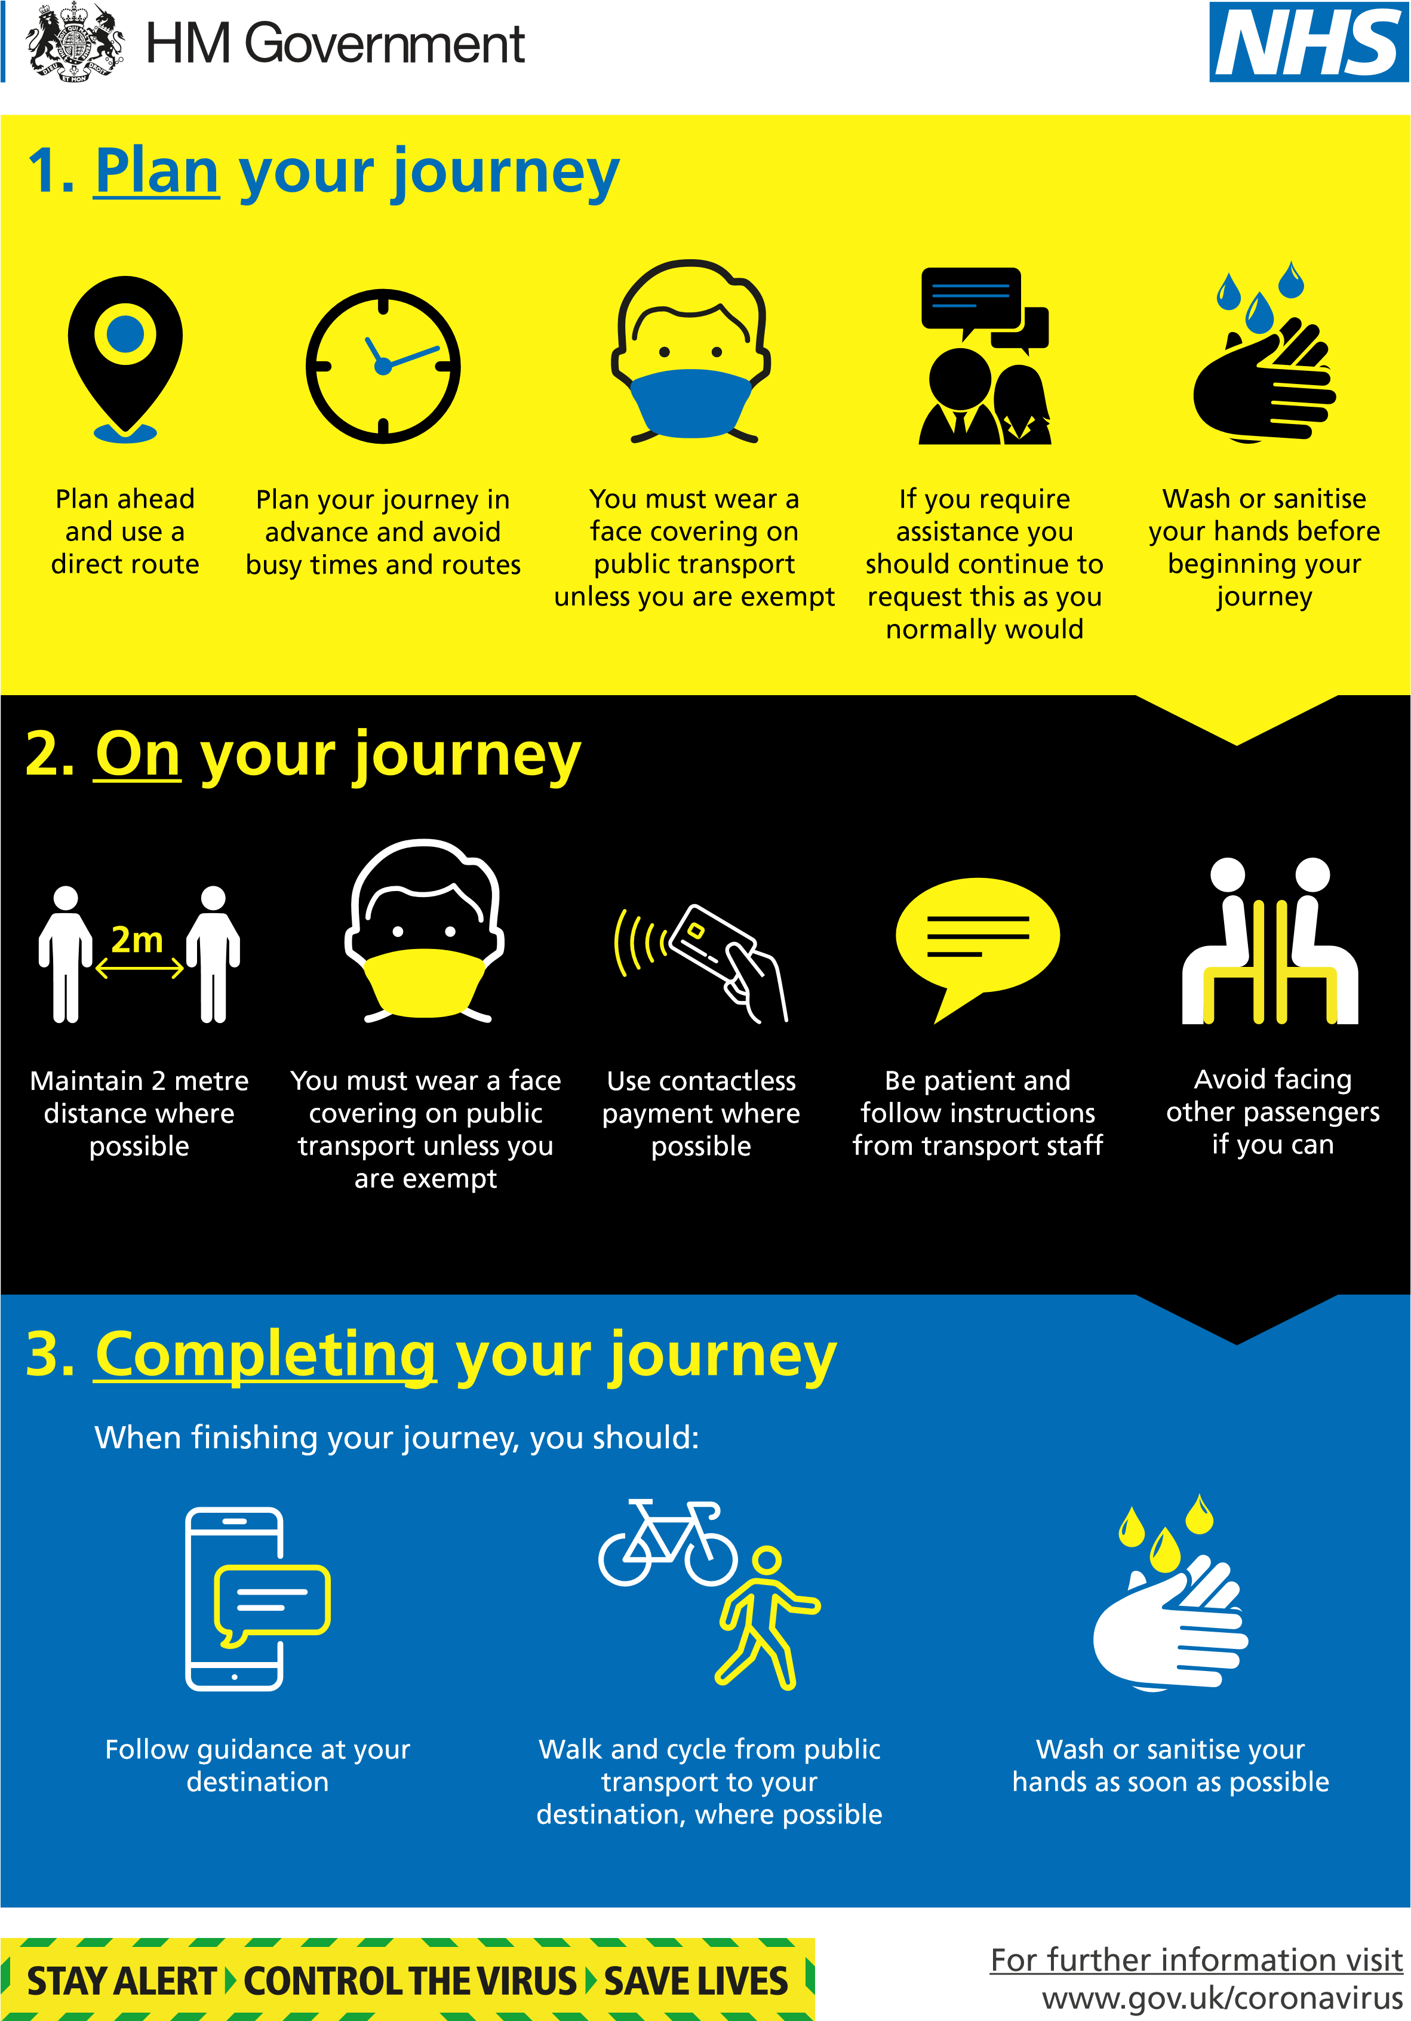

**Adult Social Care Transport**

1. Adult Social Care transport will follow the general guidelines outlined above
2. Transport for different care/day Centres will not normally be shared
3. On-bus/taxi social distancing will normally reflect that of the respective care centre and any ‘bubbles’ they employ, where possible. We may need to operate at full capacity if the infrastructure does not support continued social distancing
4. Where appropriate, the Council may offer Service Users ‘Direct Payments’ via their social worker/social work team to help ease pressures on taxi and bus provision

**Other Passenger Transport Provision**

91. The Council also provides and supports other passenger transport services, including those Community Transport and the general guidance outlined here will apply to these other passenger transport services. For community Transport in particular, the Council would suggest that the rules applying to public transport be adopted as a default, unless operating any exclusive ‘closed’ transport arrangements, where options for reduced on-bus social distancing could be considered. Specific advice can be provided by contacting the Council using the contact details below.

**Summary**

Shropshire Council greatly appreciates all the support and effort from school transport operators and our other partners in continuing to provide transport services in the Coronavirus (Covid-19) national emergency and we are always here to support you.

We implore parents, pupils, students, passengers, schools, colleges and all others involved in Shropshire’s passenger transport network, to take on responsibility for following these safety guidelines and support others in doing so.

**By working together, we can make Shropshire safe.**

Finally, for any queries please contact the Council’s Passenger Transport Group (PTG), using the contact details shown at the foot of this guidance.

Shropshire Council

12th August 2020

*Contact details:*

*Shropshire Council, Passenger Transport Group (PTG), 107 Longden Road, Shrewsbury, SY3 9DS*

*Telephone: 01743 253031 or 01743 253044*

*Email:* [*passtrans@shropshire.gov.uk*](mailto:passtrans@shropshire.gov.uk)

ENDS

*@ ‘H’ / Imp_Div/ Tran_Serv / Shared / TL Docs/Covid/School Transport Covid-19 Guidance 230720*