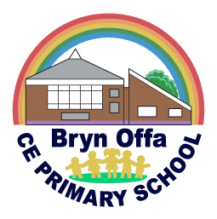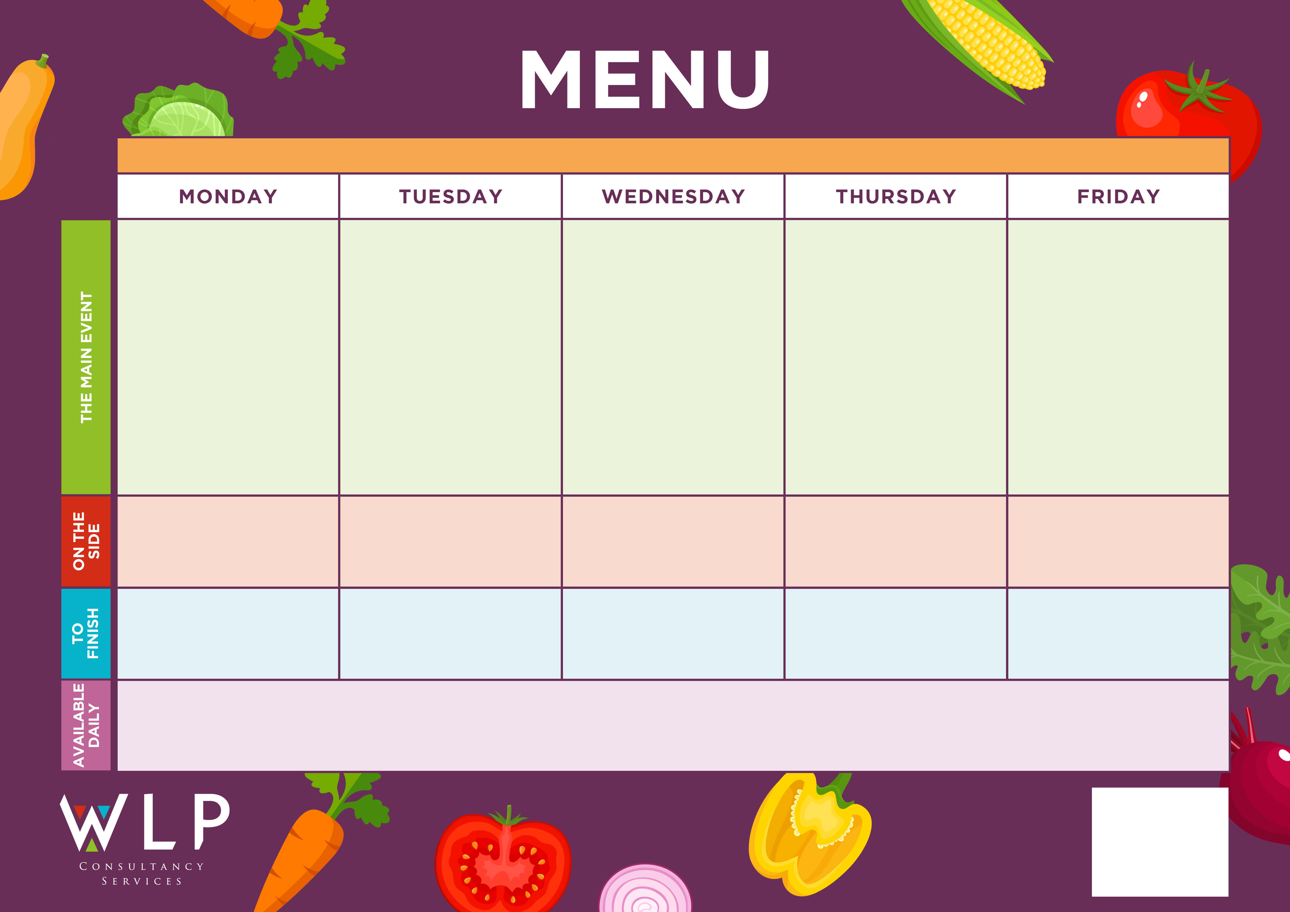

Oat & Sultana Cookie

Mandarin Jelly

Crunchy Cookie

Yoghurt

Fruit Sponge & Custard

Yoghurt

**‘Fruity Wednesday’**

Fruit Platter

Yoghurt

Chunky Chips

Garden Peas

Baked Beans

Pasta

Sweetcorn

Peas

Herby Diced Potatoes

Carrots

Green Beans

**Bryn Offa Primary School – Menu WEEK 1 – 8th Feb, 1st, 15th & 29th March 2021**

Mashed Potatoes

Garden Peas & Broccoli

Creamy Mashed Potatoes

Seasonal Vegetables

Baked Cheese Roll

Vegetarian Cripsy Crust Pizza

Pasta Neapolitan

Roasted Quorn Sausages & Gravy

Jacket Potato with Baked Beans and Cheese

Meat Crispy Crust Pizza

Oven Bake Fish

Finger

Baked Crispy Chicken Goujon & Tomato Salsa

Pork & Carrot Meatballs with Tomato Sauce (GF)

Award Winning Local Sausages & Tasty Gravy

Chocolate Muffin

*Available Daily: Fresh Fruit*