Top Tips for Keeping Well  - Be active and exercise  - Get plenty of sleep  - Talk about your feelings  - Ask for help  - Take time to relax  - Do something you enjoy  - Care for others  - Eat a balanced diet  Top tips for keeping welL | Useful websites  - Youngminds.org.uk  - Childrenssociety.org.uk  - Childline.org.uk  - Kooth.com  Speak to your teacher if you think we could support you | Mental Health Support Team working in your school  Children and Young People  5-18 years
- Worry Management  - Low mood  - Exam stress  - Difficulties with emotions  - Anxiety  - Coping strategies  - Sleep Hygiene  - Problem Solving | How can we help you?  We will be offering support by;  - 1-1 support working with you over a period of 6-8 sessions  - Small group sessions  - Whole class education/promotion  - Working closely with your teachers, parents or carers.  - School staff workshops  - Whole School assemblies  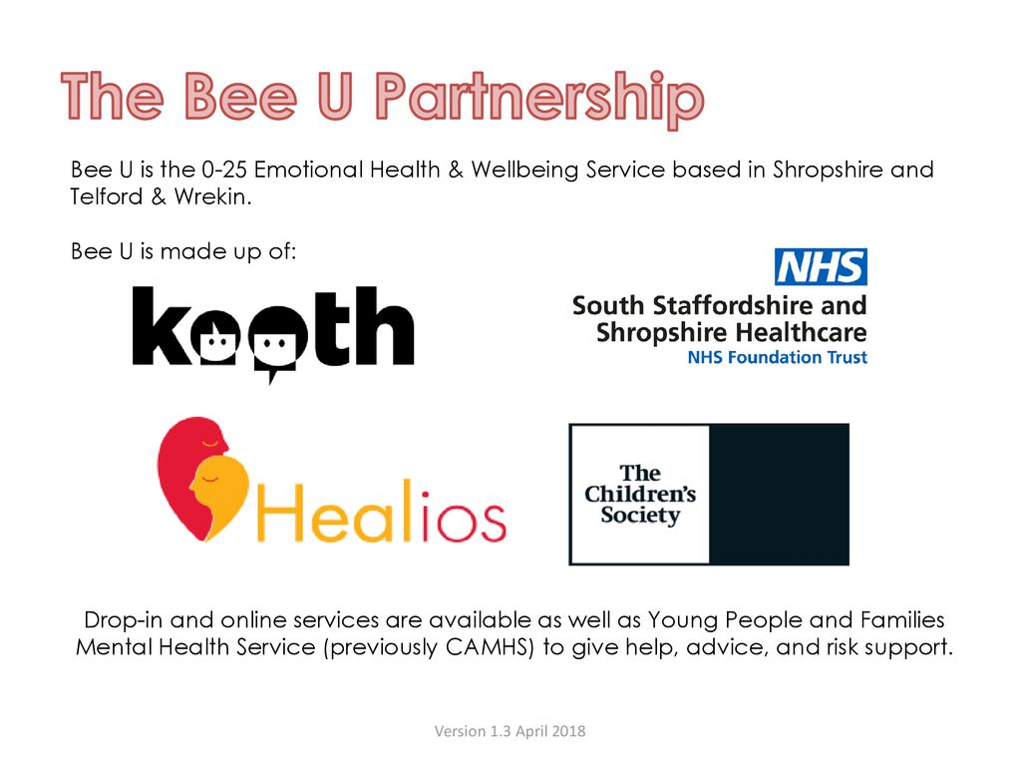 | WHO ARE YOUR EDUCATION MENTAL HEALTH PRACTITIONERS?  We are a mental health support service working with children and young people in schools in Shropshire and Telford and Wrekin.  Speak to your teacher to find out more!  “Mental health is like the weather, it is forever changing. Some days the sun will shine, and I will enjoy the warmth. Other days the rain may pour, and I will need to put my umbrella up.”  -Adapted from a young person’s thoughts on mental health
What can an Education Mental Health Practitioner help me with?

