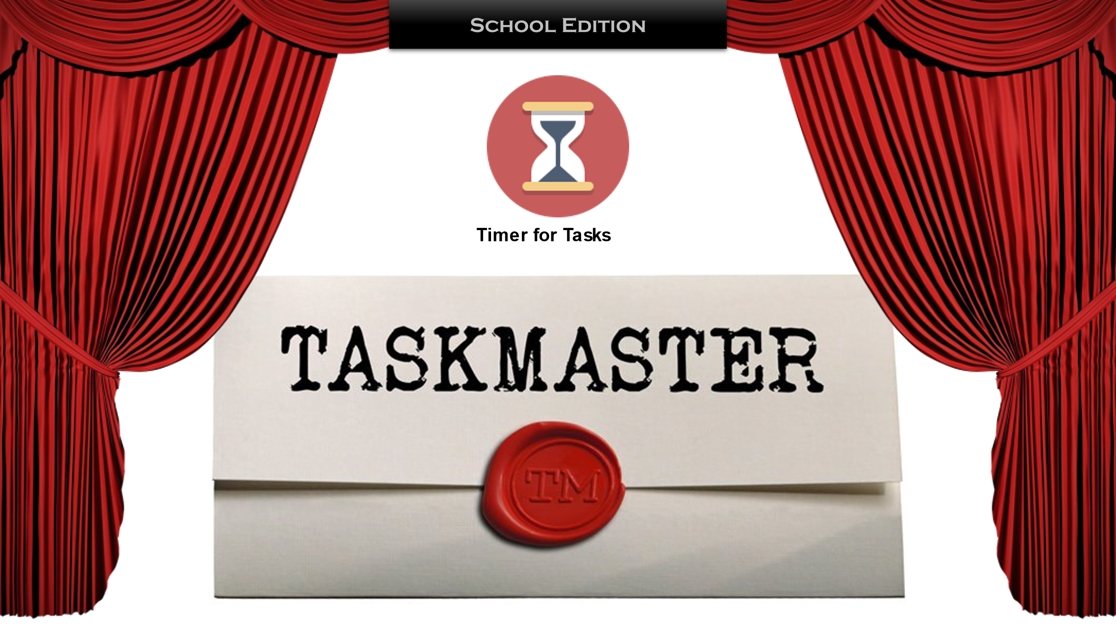

You may have watched the TV programme Taskmaster Challenge, here is the Bryn Offa Half-Term Challenge!

There are 5 optional challenges – do all of them or just one. Please send videos of you completing, or photographs of your completed challenge. There are no prizes, just a lot of fun and the glory of being on the school website!

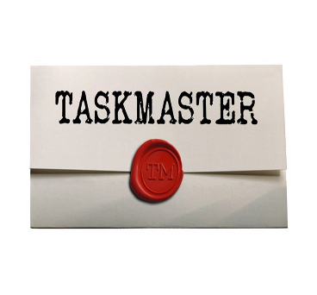**FIRST challenge**, should you wish to accept it, is collect 8 objects from around your home or garden whose initial letter spells out BRYN OFFA. Try and find really unusual objects that no one else will think of! (please write underneath which objects you used. Here are some photographs of the teachers completed challenge.



**SECOND Challenge**, should you wish to accept it, throw a teabag into a mug from the furthest distance. Please send a video of your throw and measurement of distance thrown.

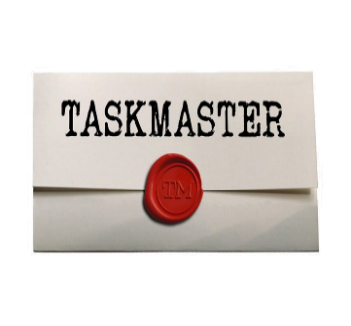

**THIRD Challenge**, should you wish to accept it, build a tower using 15 of the same object (eg. biscuits or cushions). Who can build the most interesting tower? Please send a photograph.

**:** Camera, Creativit

**FORTH Challenge**, should you wish to accept it,throw a sheet of A4 paper into a bin in the most interesting/exciting way. Could you make a paper aeroplane, scrunch the paper into a ball and use a bat or kick it in from a distance or attach it to a frisbee? Please send a video. There are some amazing ideas on YouTube – but keep safe!



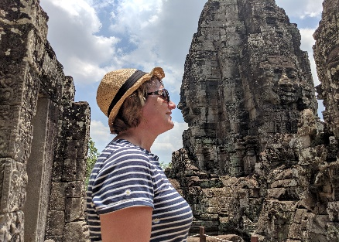**FIFTH Challenge,** should you wish to accept it, take an impressive photograph using the 'forced perspective' photography technique. There are lots of very good examples online.

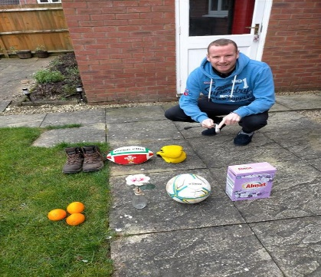  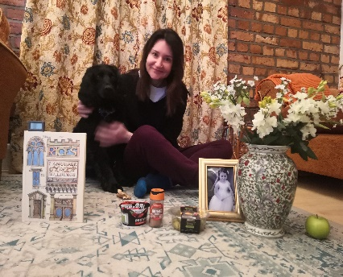

**B**oots **B**ow **B**ook  
**R**ugby **R**ainbow **R**alph

**Y**ellow **Y**east **Y**oghurt  
**N**ine (need to look closely) **N**ecklace **N**utmeg

**O**ranges **O**live oil **O**lives  
**F**lower **F**lowers **F**airy  
**F**ootball **F**rame **F**lowers  
**A**lmat **A**loe Vera **A**pple

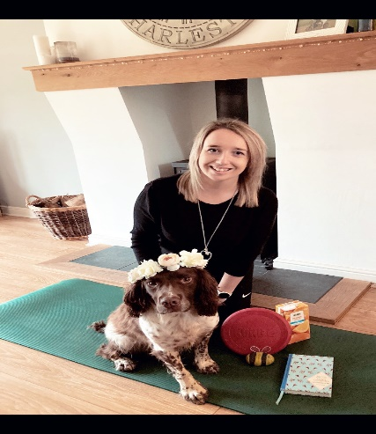 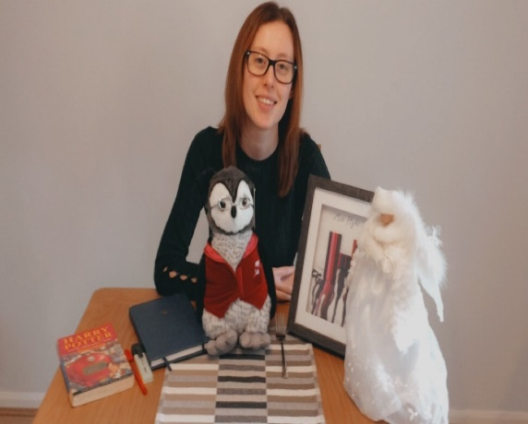 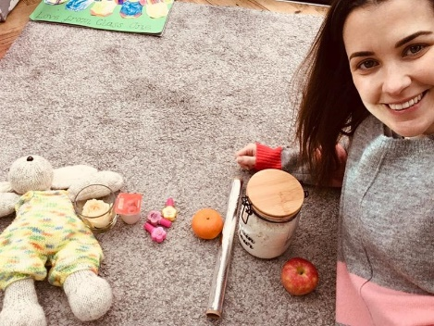

**B**umblebee **B**ook **B**unny

**R**alph **R**ed pen **R**ose

**Y**oga mat **Y**ellow pen **Y**oghurt

**N**ecklace **N**otebook **N**ail Polish

**O**range Juice **O**wl **O**range

**F**risbee **F**ork **F**oil

**F**lowers **F**rame **F**lour

**A**lice in Wonderland A**ngel A**pple

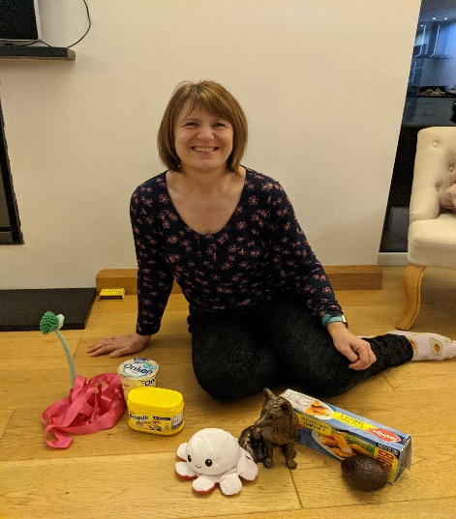

**B**rush

**R**ibbon

**Y**oghurt

Nesquik

**O**ctopus

**F**ox

**F**ishfingers

**A**vocado