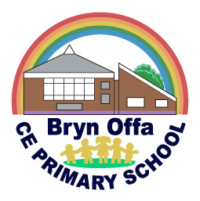
Bryn Offa Church of England Primary School
Rockwell Lane, Pant, Oswestry, Shropshire, SY10 9QR
admin@brynoffa.shropshire.sch.uk
Tel: 01691 830621
Headteacher: Mr P Thompson

2 x Level 3 SEN Teaching Assistant Position
Permanent (Role dependant on continued attendance and funding)
2 x Part Time – One morning (3.25 Hours) and one afternoon (3.25 hours)

Bryn Offa is a very special place to work, mainly due to the amazing staff who work here and the fantastic children. Our philosophy is that we train staff to allow them to leave, but treat them so they want to stay.
We are looking for two kind and caring teaching assistants to fill the role for supporting a high needs child starting school in September 2021. One of the roles will be for the morning session and one for the afternoon. The plan is for the afternoon role to cover the lunch break, due to the afternoon being a shorter session. Some flexibility to work full days in the event of the other half of the job share not able to attend would be good, but not essential.
As the role is supporting a high needs child with ASC, the qualities that should come through the application and interview process are:
- Kind and patient
- Insight into the difficulties experienced by a child with Autistic Spectrum Condition
- Willingness to take necessary training
- Comfortable with providing intimate care for a high needs child
- Understanding of how a high needs child can be integrated into the class
- Ability to react to the changing needs of a child
- An understanding of how a high needs child should be supported during the break times
- An understanding of the demands of supporting a child 1 to 1

Experience and qualifications at the correct level are essential for this role.
Visits to the school to meet the headteacher and SENCO are welcome, but are likely to be outside in our Alpine Shelter and are unlikely to include an internal tour of the school. These must be organised by calling the school on 01691 830621 and speaking to Miss Morris (our Administrator)
Closing Date for Applications – 19th April 2021 by 12:00 lunchtime
Shortlisting – 19th April 2021
Interview Date – 30th April 2021

Please note that if you are shortlisted for the position, it is at this point that we will take up your references.
Application forms and additional information can be downloaded from the LA website, or requested from school by emailing:
admin@brynoffa.shropshire.sch.uk

This role will be subject to enhanced DBS checks and further checks on rights to work in the UK.

