Emma Răducanu (born 13 November 2002) is a British tennis player. She was born in Toronto, Canada to a Romanian father and a Chinese mother, who both work in finance. Her family moved to London when she was aged two because they thought it would be an exciting place for her to grow up. She started playing tennis at the age of five at the Bromley Tennis Academy. She was a pupil at Newstead Wood School, a state grammar school in the London Borough of Bromley.
Before she played at Wimbledon 2021, her highest WTA singles ranking before this weekend was No. 333, on 9 March 2020. She has won three singles titles on the ITF Circuit. This weekend she became the first British female tennis player to win a grand slam in 44 years!
Along the way to her amazing achievement, she broke a number of records too!

With the victory, Raducanu becomes:
- The first British female winner at Flushing Meadows since Virginia Wade in 1968
- The first qualifier in the Open era to win a Slam
- The youngest women's Slam champion since Maria Sharapova at Wimbledon in 2004
- The youngest Briton to win a Grand Slam title
- The first woman to win the US Open without dropping a set since Serena Williams in 2014
She will take home £1.8m in prize money, rise to 23 in the world rankings and will become the British number one on Monday.

Astonishing. Ridiculous. Meteoric. Unbelievable. Take your pick - but no word can ever really sum up what Raducanu has achieved.
Two weeks ago, Raducanu had a flight booked back to the UK, just in case she did not come through qualifying in New York. Seventeen days later, she has lifted the trophy in front of a rapturous crowd. No-one could have seen this coming; not the ease with which Raducanu would brush her opponents aside, or the calmness with which she would approach every match.

Former Wimbledon champion Pat Cash said: "I cannot believe it. It is unheard of for a qualifier to win the US Open. Goran Ivanisevic won Wimbledon as a wildcard but he had already been to Wimbledon finals, not playing a second Grand Slam.
She hits so cleanly. I cannot come up with a reason for this to happen. It does not make sense at all. Her performance is mindboggling."
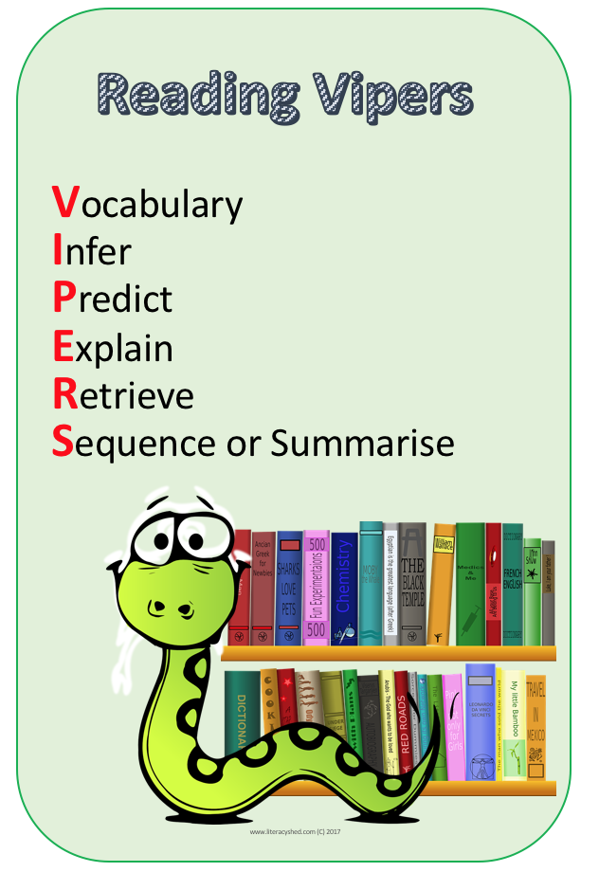
V1. What 4 words are used consecutively in the text to describe her fantastic win?
V2. What does the word ‘ranking’ mean?
V3. Find a synonym for ‘winner’ in the text.
V4. What word is used that shows she hid her nerves? (if she had any!)
V5. During the Pat Cash quote, he gives his opinion on how well she played. What word does he use to show how amazing it was?
V6. What does the word rapturous mean?

I1. What makes us think that this was an amazing achievement? Use evidence from the text to support your answer.

P1. How do you think Emma Raducanu will do in the future? What makes you predict this?

E1. Explain what you think this means for British tennis. For example, what impact might this have on children?
E2. Even Emma Raducanu wasn’t expecting to do as well as she did. Explain, using the text, how we know she didn’t expect to do so well.

R1. Where was She born?
R2. Where were her parents from?
R3. Write down 2 British records she broke by winning this tournament.
R4. How much money will she make from winning the tournament?
R5. What was her highest rank before and what British rank will she become this week?
S1. In a ‘tweet’ of no more than 25 words, summarise Emma Raducanu’s achievement.

